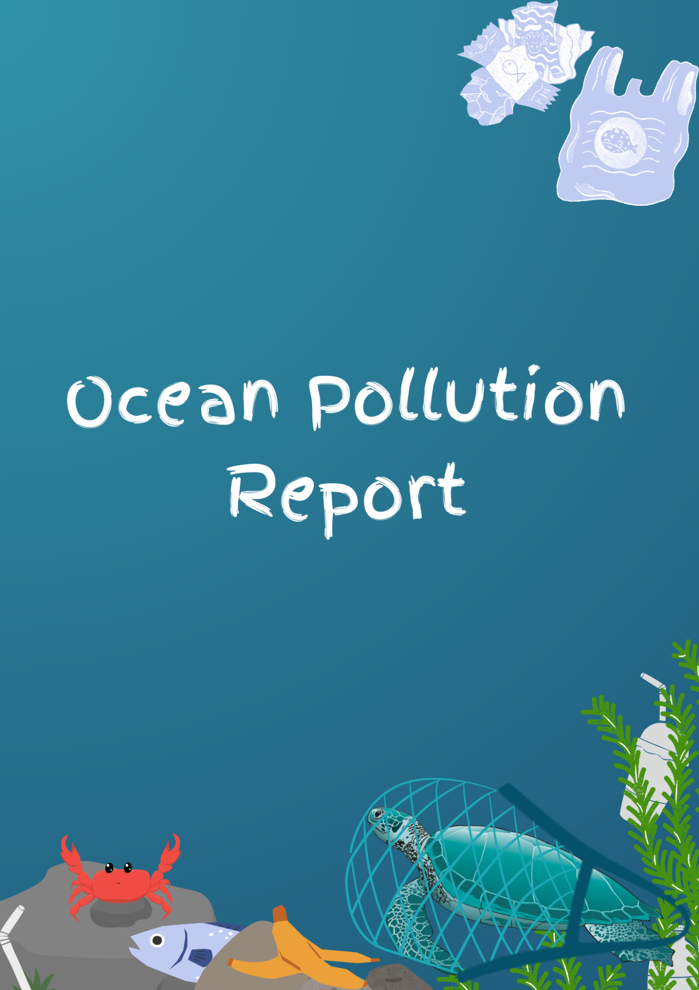

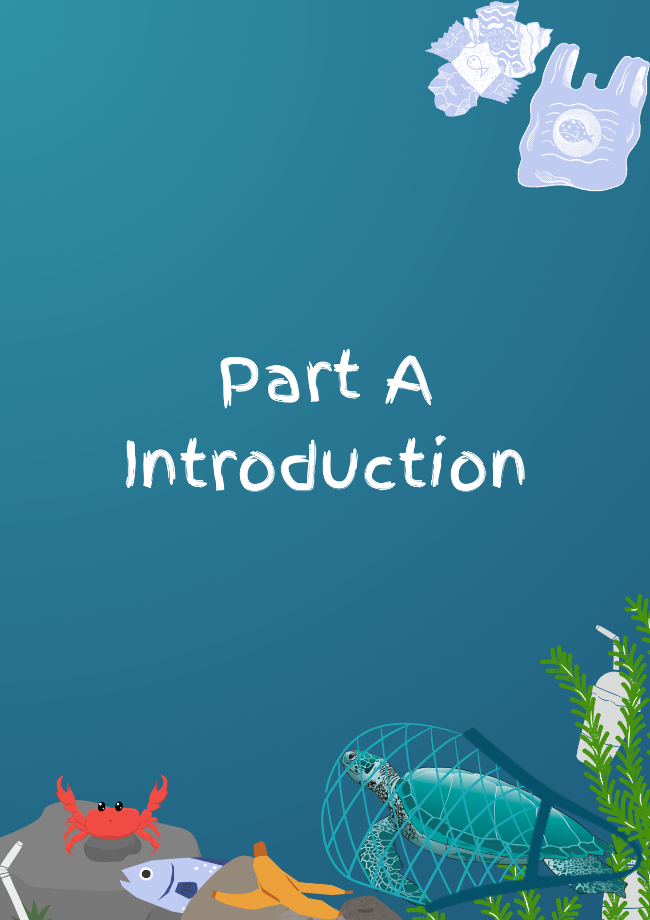
As I write this and as you read this, rubbish
is being thrown into the ocean.
Undeniable and inevitable its existence, though much
to our displeasure.
Yet despite it becoming more and more present as time goes on, never do we seem to do anything about it.
If we bring our oceans to the edge of collapse, how do you think that will impact not just them, but us?
We do not have 50 years spare time to plan our recuperation
If we want to rescue our oceans, then we need to act now
The tools are at our disposal, why not use them?
I hope, and I presume you hope too, that we will do better
May the ocean recover

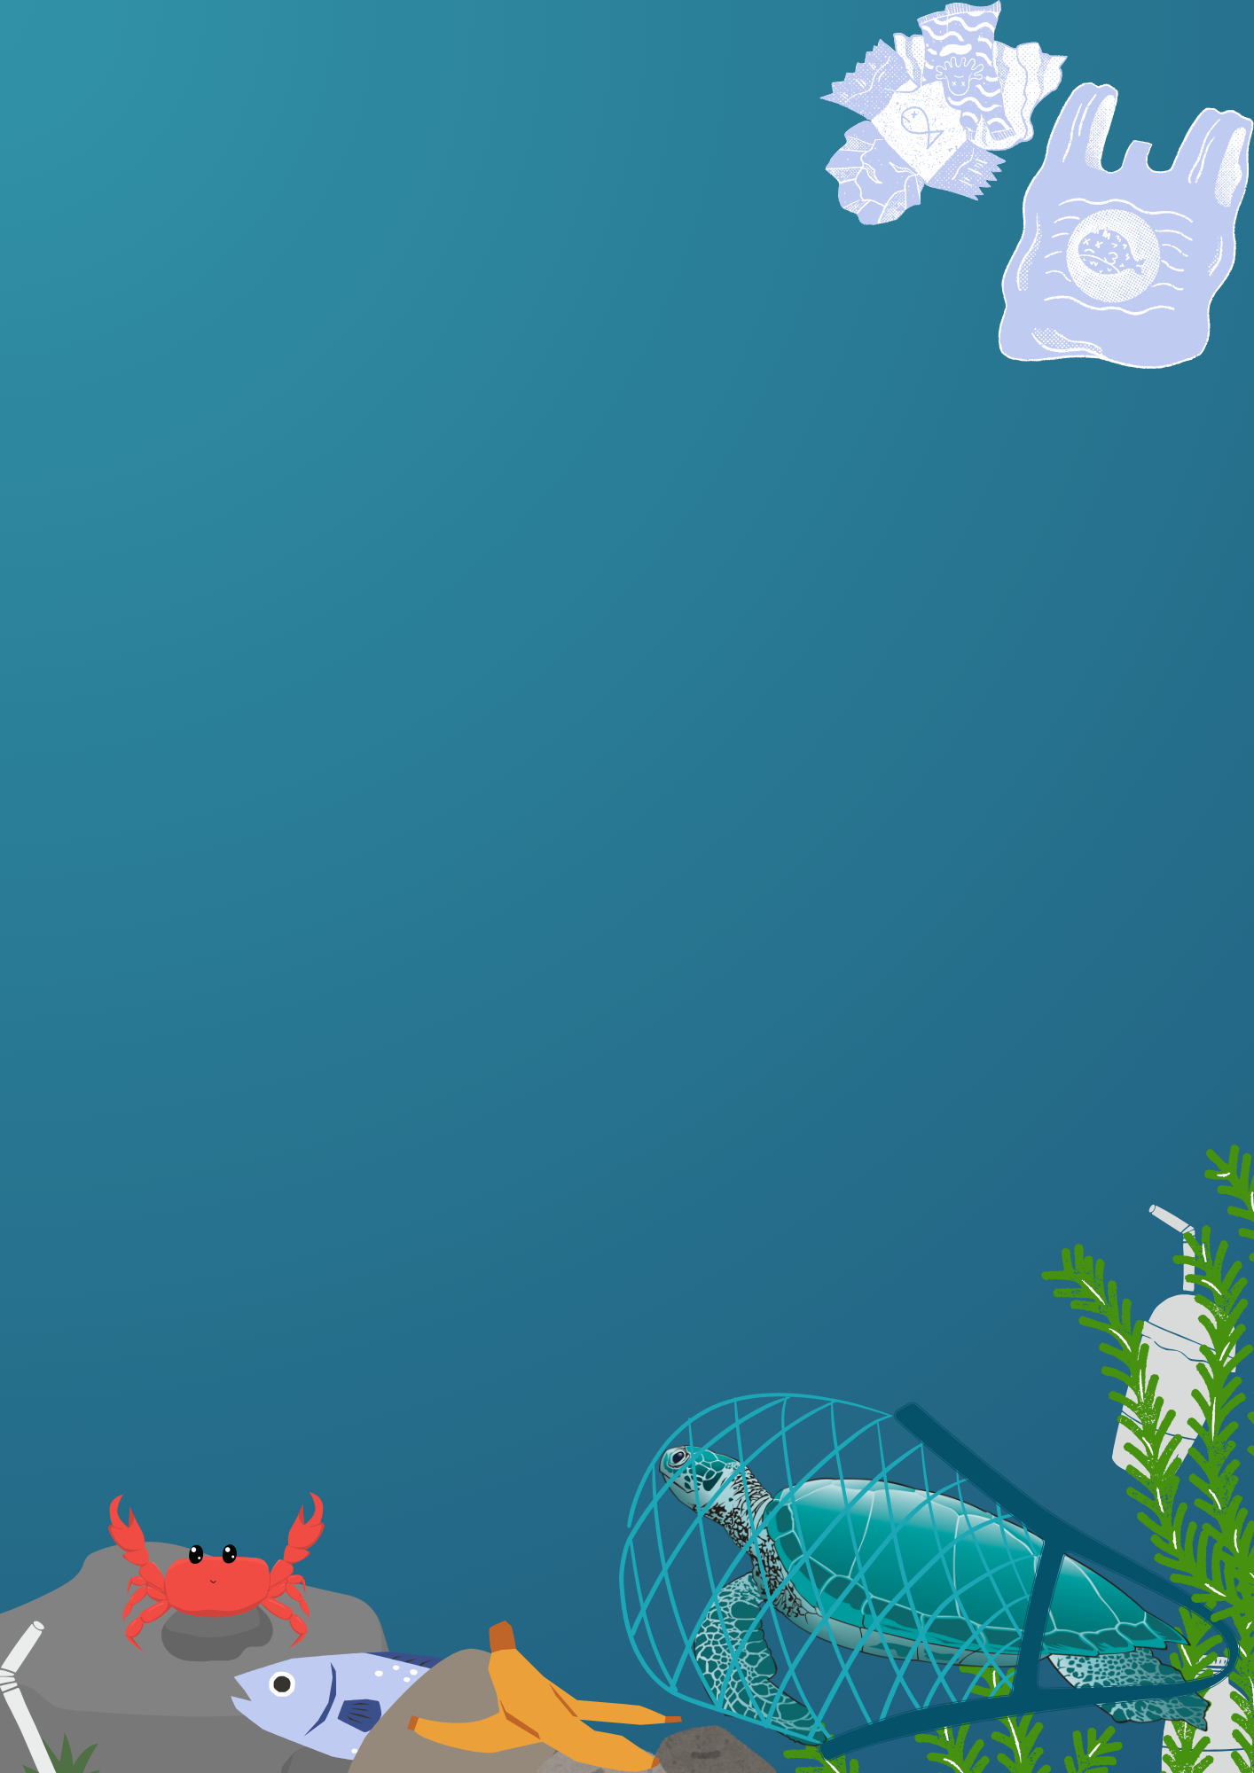

Every year we throw over 8 million tonnes of
rubbish into the ocean for an estimated total of
5.25 trillion pieces of plastic floating about, or sinking to the
depths of our oceans. But ocean pollution isn’t a surface deep
issue, over a quarter of all man-made carbon emissions end
up in the oceans, affecting more than just a few unfortunate fish who can’t tell prey from plastic. Carbon dioxide by itself is not too harmful I suppose, but as it dissolves into the water, it combines to make a compound called carbonic acid, which unsurprisingly turns our oceans into an acidic wasteland. Fish live and breathe in this acidic water and due to the lower pH level, develop a condition called acidosis. But worse than a fish’s ‘acidosis’ could be the erosion of shells in the ocean. There are solutions to these issues, but without proper private or public support we cannot enact them. I hope that in the following pages I can raise awareness for this cause.
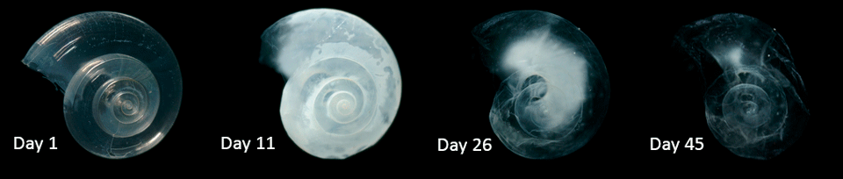
Progress of a (replica) shell eroding in acidic waters

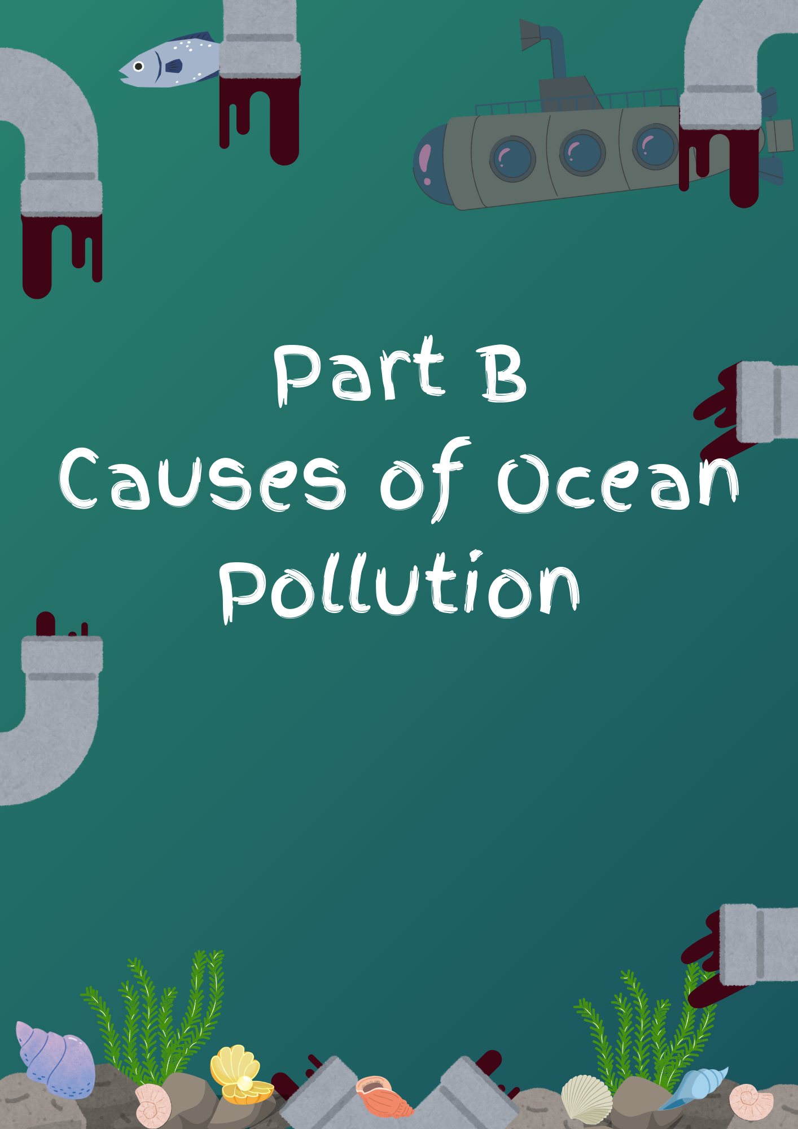

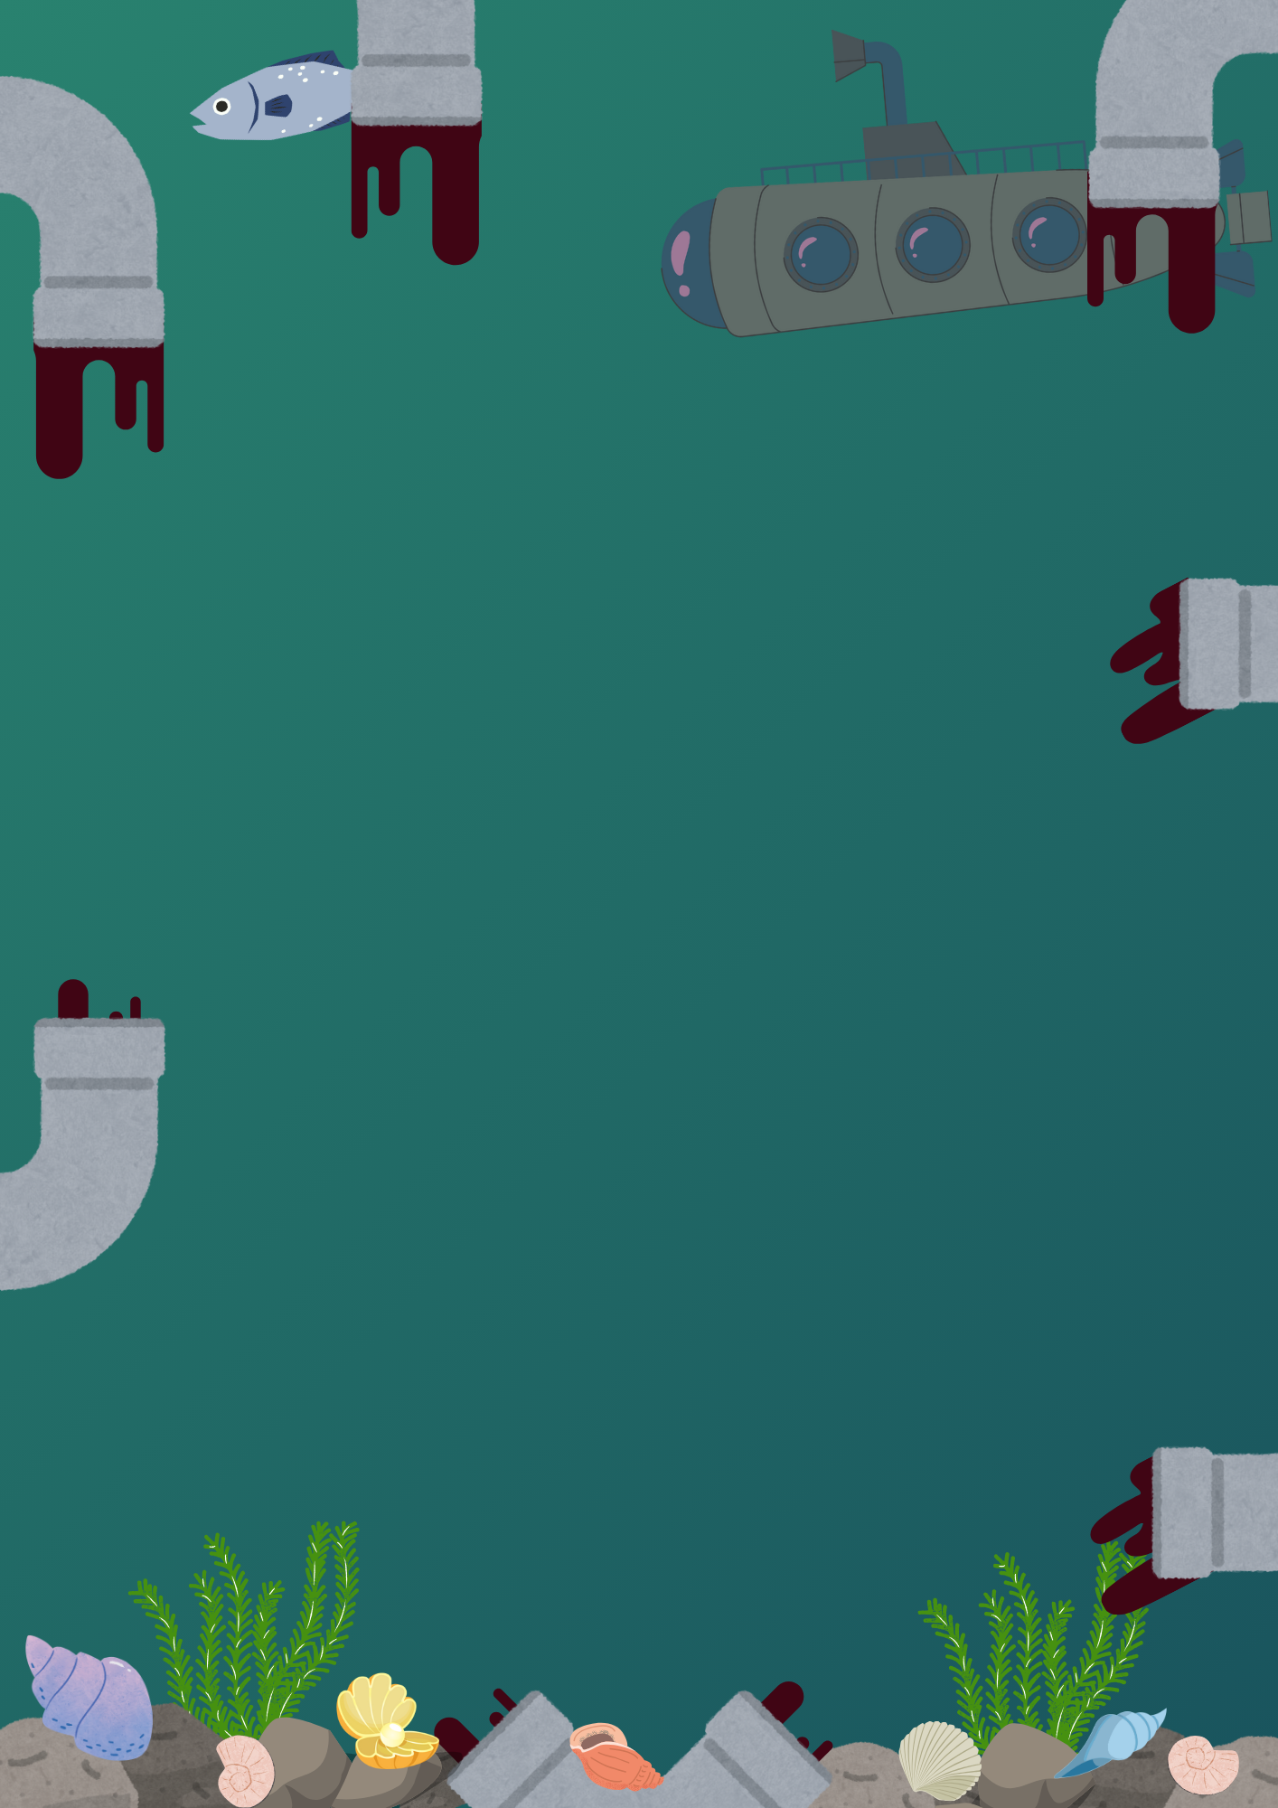

So what is contributing to our ocean’s pollution?
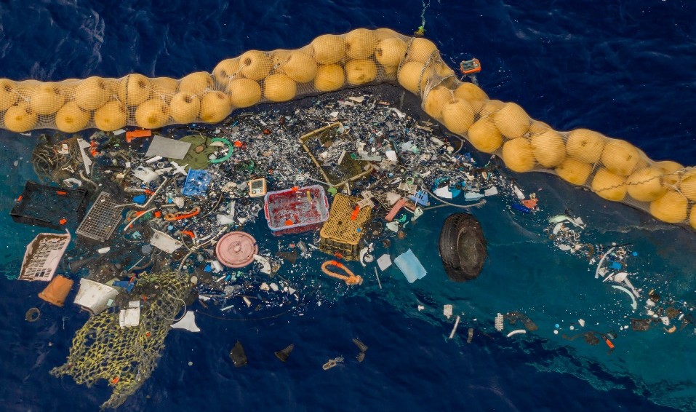
There are several factors, each of which I will go into a short amount of detail now:
Plastic pollution:
As I outlined earlier, we as a society throw out over 8 million tonnes of rubbish each year. From a tiny plastic straw to a large tub, every item seems to have a limited lifespan, and after that lifespan is up, out to the trash and inevitably to the ocean it goes. There are several patches in the ocean, the largest of these being the Great Pacific Garbage Patch. Thankfully, the amount of trash getting in the ocean has steadily fallen since 2017 in several countries, however at the rate we are currently going at, the issues caused by plastic pollution, which I will go into later, are only going to get worse and worse.

A portion of the Great Pacific Garbage Patch

Land runoff pollution:
Despite the default idea that all ocean pollution, or at the very
least, most ocean pollution is produced from our overuse of
plastic, this is not the case. Having the worst effects over our
oceans, land runoff pollution such as non-point pollution makes up 80% of our ocean pollution. Every day: cars; trucks; farms; ranches; you name it, they all contribute a little piece to the pie by dropping small amounts of oil, or contribute a little bit to air pollution. Eventually, all of this pollution adds up over time and creates a toxic environ meant for fish, coral, shells, and any
other poor creatures.
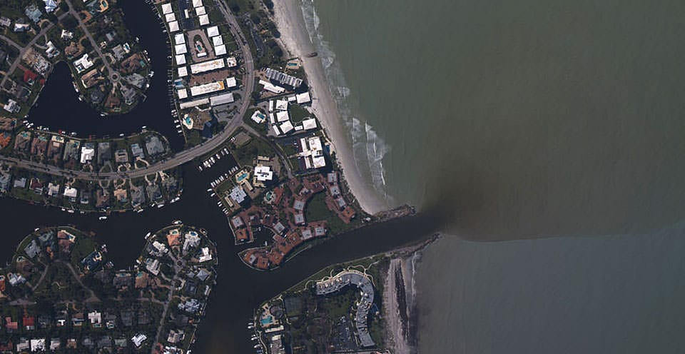
When large tracts of land are ploughed, the exposed soil can erode during rainstorms. Much of this runoff flows to the sea, carrying with it agricultural fertilizers and pesticides

Light pollution:
A much less talked about form of ocean pollution has nothing to do with harmful chemicals, or mountains of plastic piling up in the ocean. Picture yourself as a fish, who uses light to guide yourself through the world, and all of a sudden, it just never seems to stop. One day, light always surrounded you. Of course, light pollution didn’t just happen overnight, but I want to stress its importance. The night sky grows around 10% brighter each year; in city centres it is now impossible to even see the brightest of stars. If our light can drown out the stars, what do you think it will do for our marine friends?
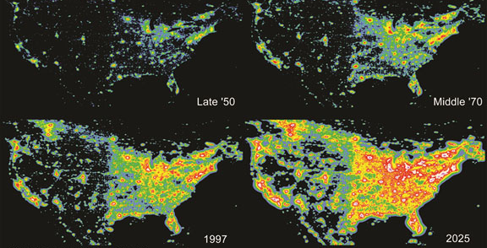
How much light pollution is present in the ocean in the U.S., note that light pollution affects coastal regions more so than deep oceans.
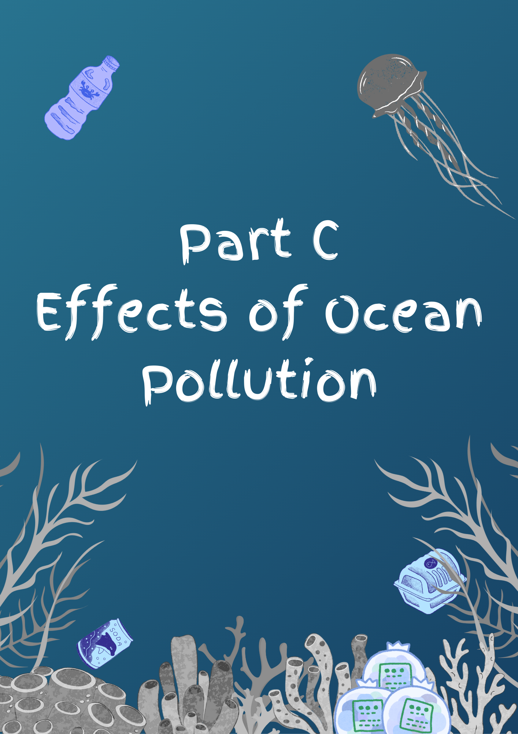

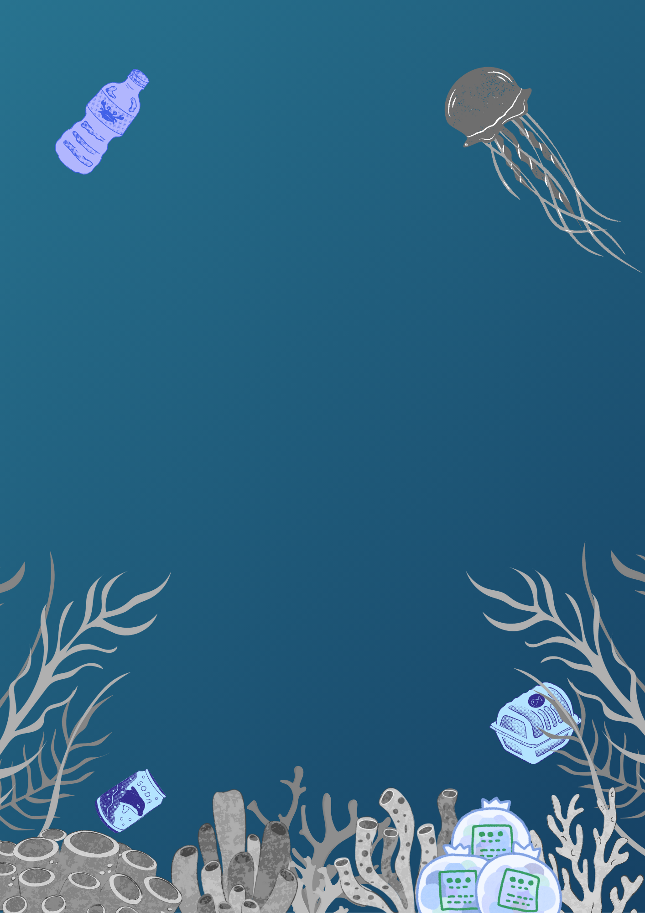

Effects of plastic pollution
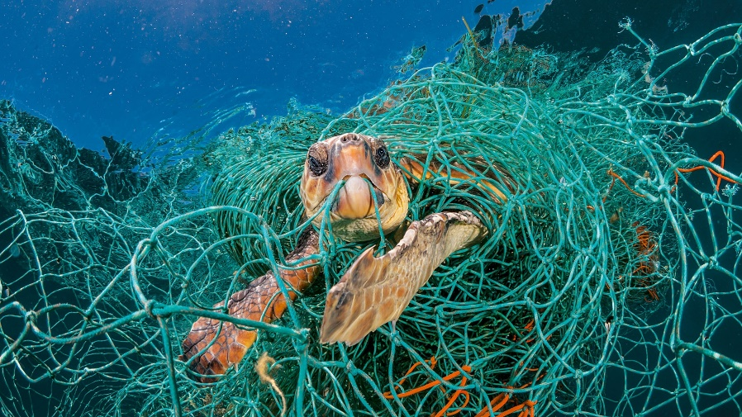
So now that we’ve discussed a few of the various causes, what is the impact for each of these causes? Starting with plastic pollution, why not cover the thousands upon thousands of fish, turtles, dolphins, and creatures of all sorts that are caught in, or end up eating plastic. However, I think that thousands is a little bit low of an estimate, because the real statistic is that over 100,000 marine animals die from eating or being entangled in plastic. Why? For different sea creatures, the reasoning is different. Aquatic mammals (dolphins, sea lions, etc…) are found to be curious about their surroundings, often at the expense of their lives; turtles can think that a plastic bag is their next jellyfish snack; some fish get entangled in fishing gear that has been discarding, essentially ‘ghost fishing’, truly the list could go on for a while. Sea creatures just aren’t smart enough to tell prey from plastic, and we need to recognise that and properly dispose of our plastics
A turtle stuck in a fishing net

Effects of too many chemicals
As we’ve discussed earlier, land runoff pollution is the main cause for the overload of harmful chemicals that are present in the ocean, however that is not to say that it is the only cause for this one. The effects of a whole society continuously using up its natural resources for gain and more gain only makes our oceans more and more toxic. We’ve discussed earlier the effects that toxicity has on shells, to build on that, approximately 50 years ago; shells on most shellfish were 32% thicker. This decreasing thickness in their shells makes shellfish vulnerable to attacks from predators, and if these creatures decline, then so will said predators who will no longer have any chow. Though technically unrelated, I also want to mention that our society’s overuse of chemicals also harms our land by raising the global temperature, melting Earth’s icecaps, therefore raising our global sea level and, flooding our coasts and coastal regions.
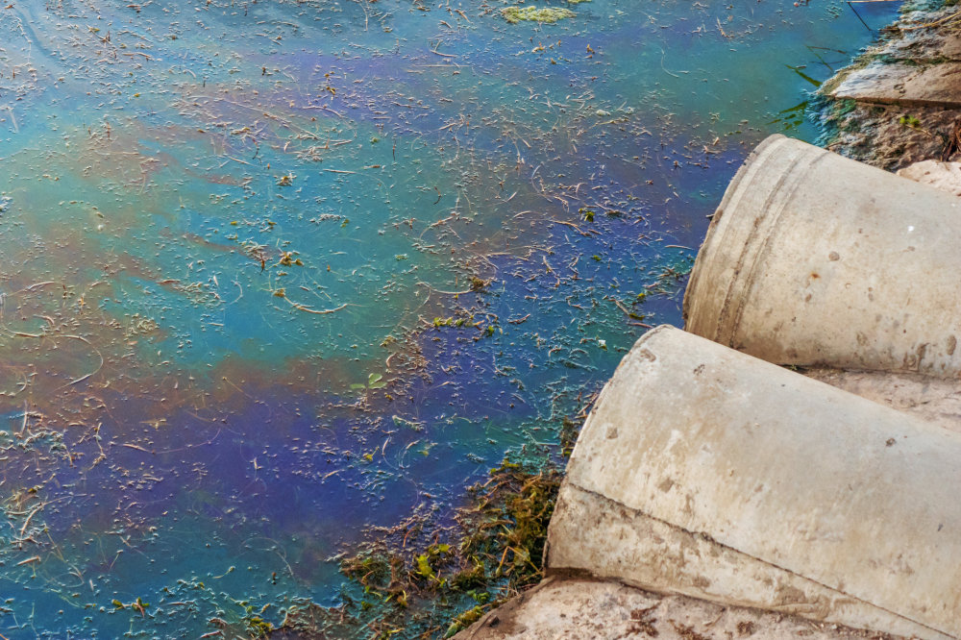
How chemicals can affect the colouration of certain water bodies

Effects of light pollution

Whilst light pollution is an issue that at first can be seen as being mostly land based, it has seriously harmful effects on our beaches and coastal regions too. There aren’t any generalisations I can make, but I can give specific examples for various critters. How about the New Born Sea Turtle: when sea turtles hatch, one of the main ways that they find their way to the ocean is by searching for the brightest area, which is always going to be the shimmer of moonlight reflecting of the surface of the ocean. However, with our own artificial lights now shining, the brightest area to go to now appears to a sea turtle as the land it should be trying to get away from. This confuses them, and can ultimately end the lives of many poor young sea turtles. Another example could be sea coral. They can often spawn on other nights than when they should be due to the increased light in the sky, which can mean they won’t end up being fertilised, ultimately resulting in the loss of our coral reefs.
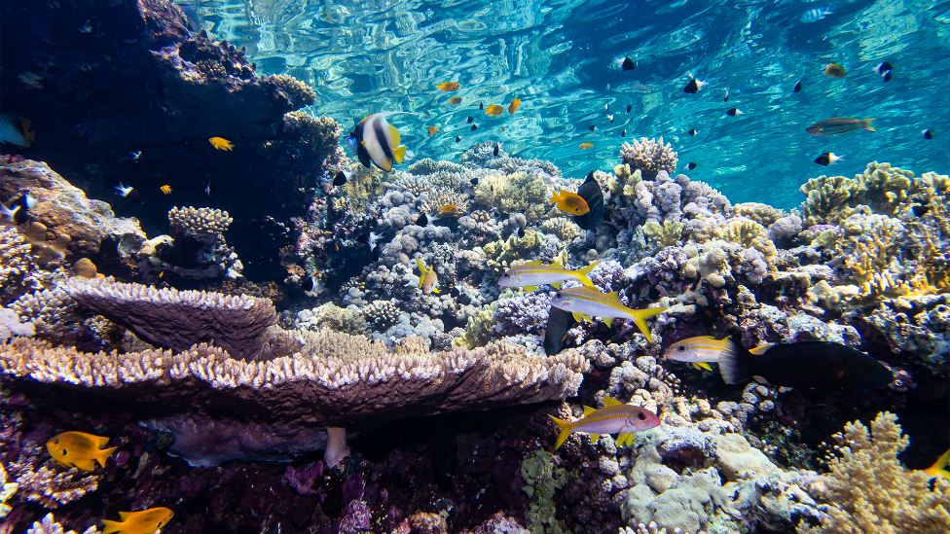
A coral reef in the red sea that is particularly affected by light pollution
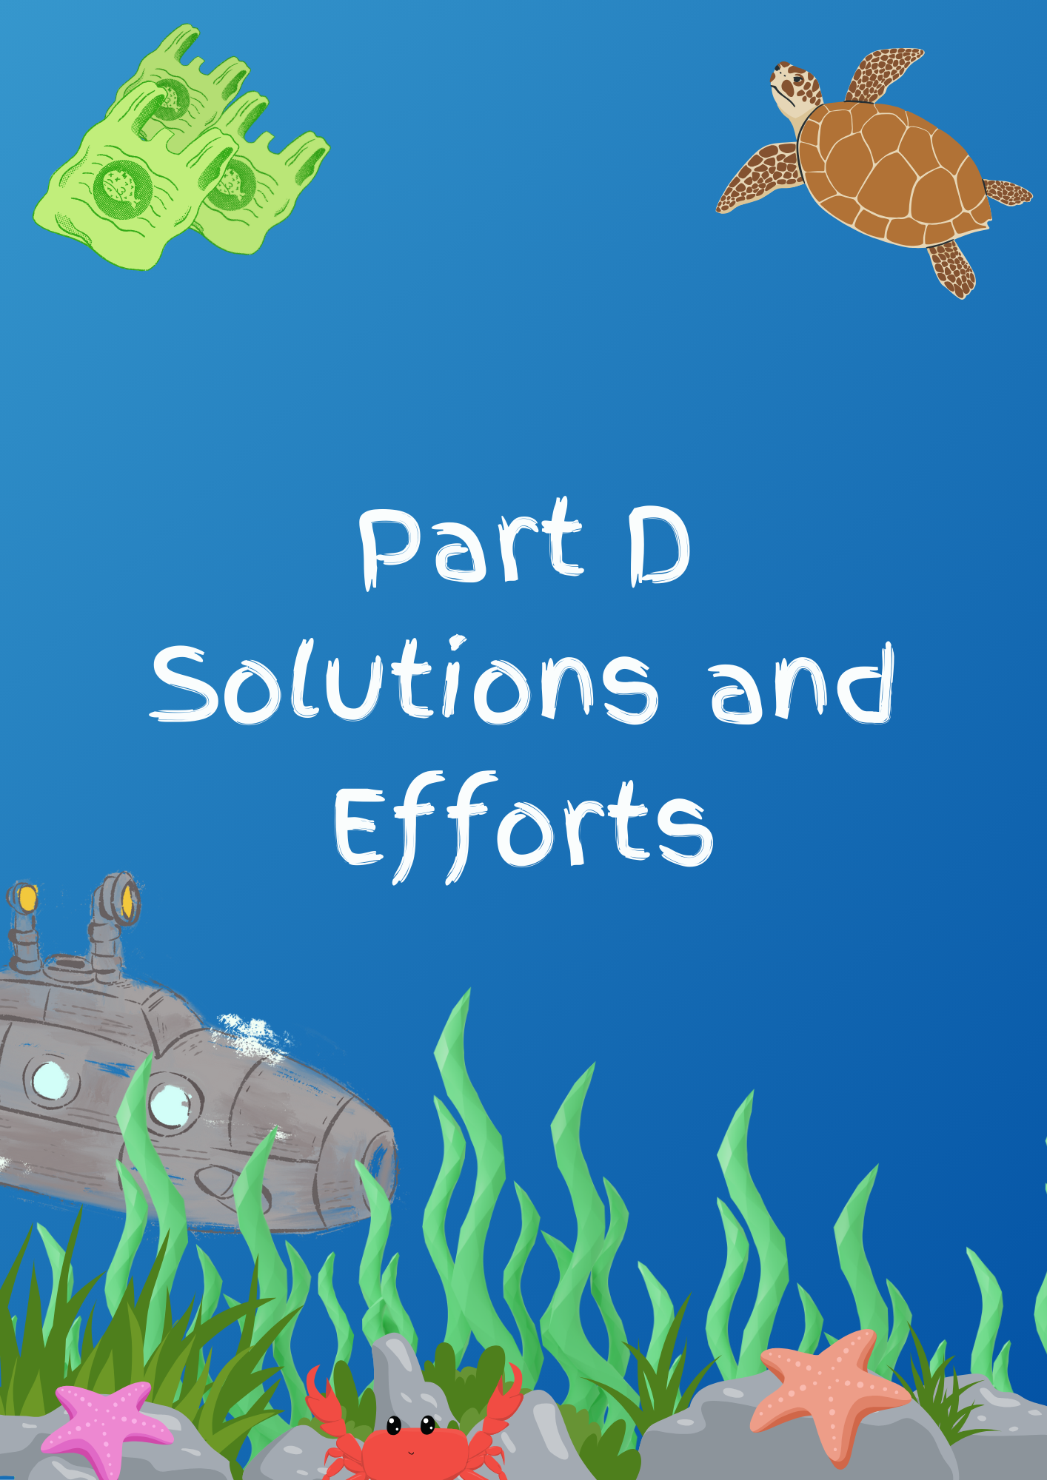

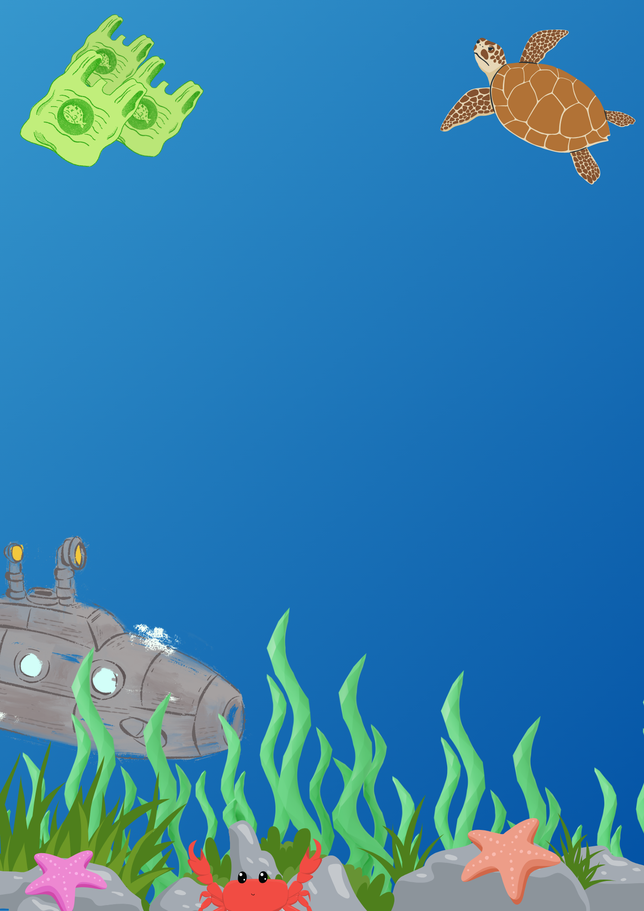

Solutions for plastic pollution

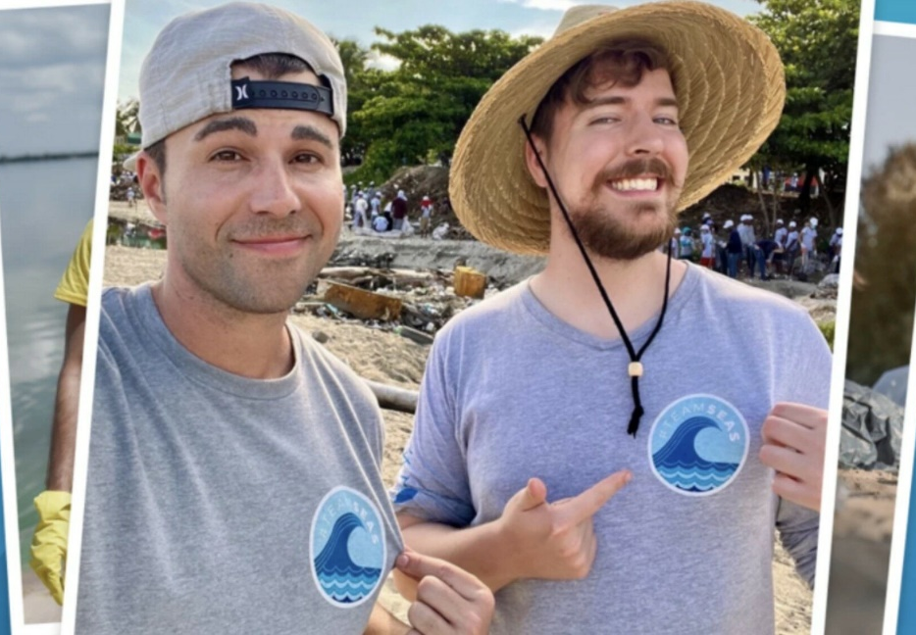
Plastic pollution seems like an easy task to fix at first, just pick up all the rubbish. However, once you actually consider just how much plastic there is to pick up, it becomes apparent why the problem is still there. Popular YouTuber Mr Beast joined up with the ocean conservancy charity in 2022 to form #TeamSeas, a program designed to help support the picking up of rubbish. Anyone around the world could donate $1usd to the cause, and the organisation would pick up 1 pound of trash. In total, this Program (has so far) raised around 33,000,000 lbs of trash, or 12,000,000 kg. However, this is nothing in comparison to the 8 million or so tonnes of trash that enter our ocean each year. To put that into perspective, even if we put this amount of effort into cleaning up our oceans each year, we’d only clean up 1.9% of the trash that winds its way up into the oceans. A better way to clean up the ocean, is to stop plastic from entering in the first place. Many governments (including Australia’s) have started banning single use plastics. If every government around the world did this, we would save hundreds of millions of dollars as well as our oceans.
Mr Beast Posing with Mark Rober after passing $30 million

